**MASTER-SLAVE**

Master-slave architecture (often referred to as Controller-Agent in modern terminology) distributes build and testing tasks across multiple machines. This setup helps manage large-scale continuous integration and deployment pipelines effectively.

**MASTER SLAVE ARCHITECTURE:**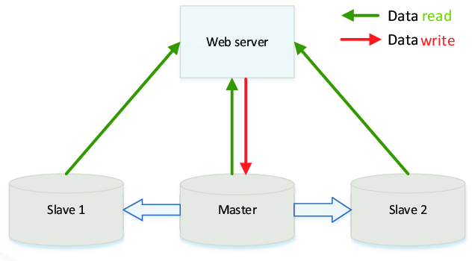

**Why Use Master-Slave Architecture in Jenkins?**

* **Load Distribution:** Offloading builds to slaves reduces the workload on the master and improves performance.
* **Scalability:** Enables the use of multiple machines, allowing for parallel execution of builds.
* **Environment-Specific Builds:** Different slaves can be configured for specific environments (e.g., Java, Python, Windows, Linux).
* **Fault Tolerance:** If one slave fails, others can continue executing tasks, reducing downtime.

**Master (Controller):** The Master is the central Jenkins server.

**Slave (Agent):** The Slave is a remote machine (physical or virtual) that performs tasks assigned by the master.

**Create Ubuntu Master and Node instance in AWS console:**

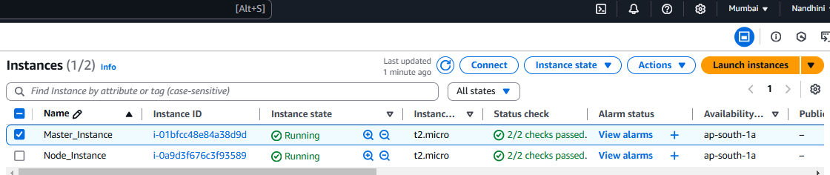

**Update the server and check for java connection:**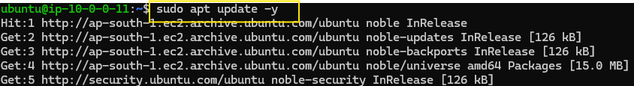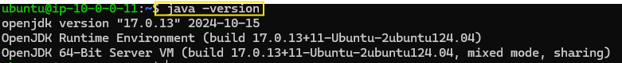

**Install Jenkin in Ubuntu Master server and connect through public ip:**

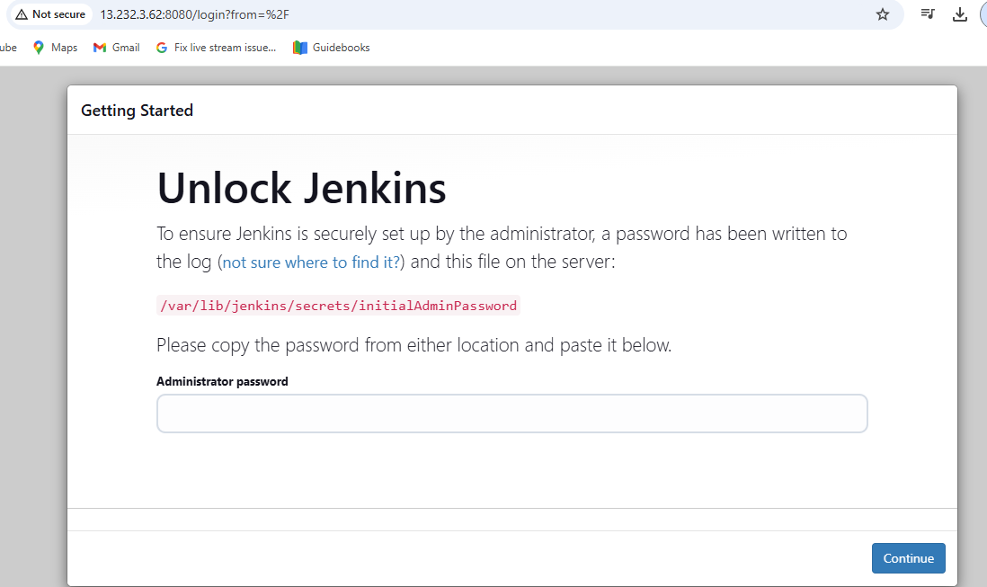

**Setup in Jenkins**

**Add a Node (Agent): Navigate to Manage Jenkins > Manage Nodes and Clouds > New Node.**

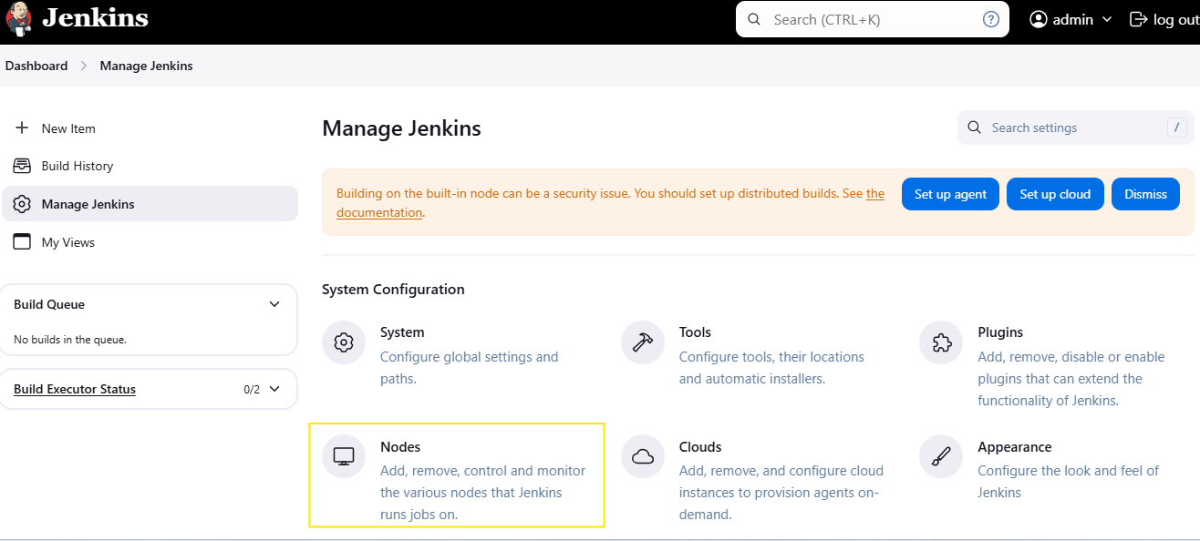

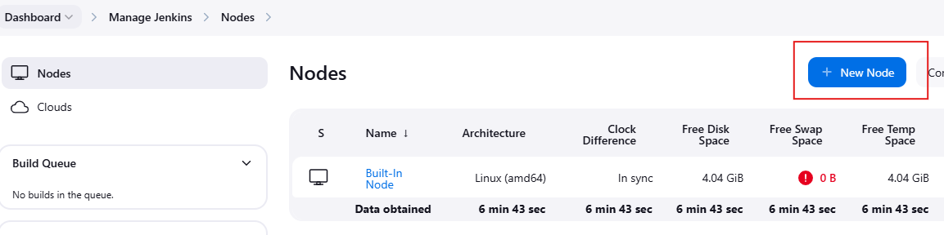

Configure the node by specifying its name, remote directory, and usage.

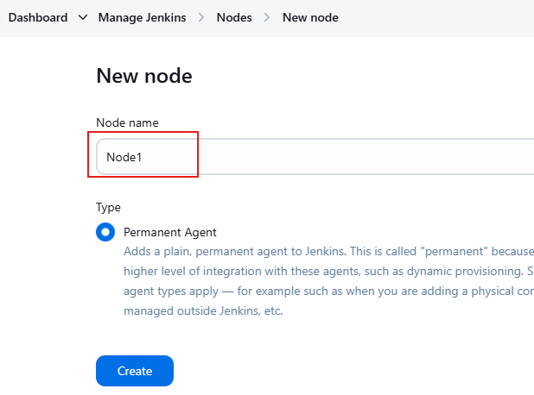

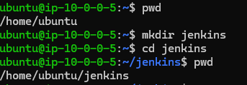

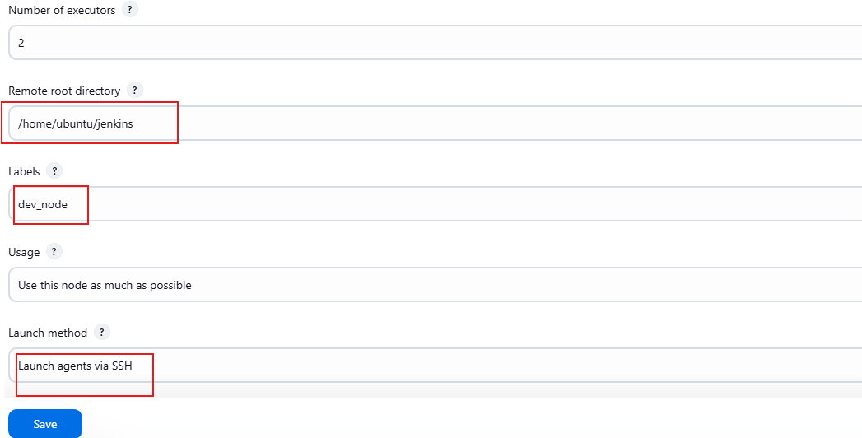

**Establish Communication**:

Use SSH for the agent to connect with the master. Ensure the agent has the necessary permissions and credentials.

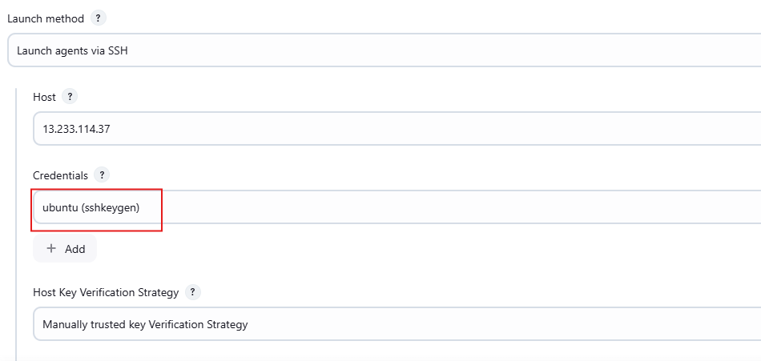

Launch agent if it is in offline:

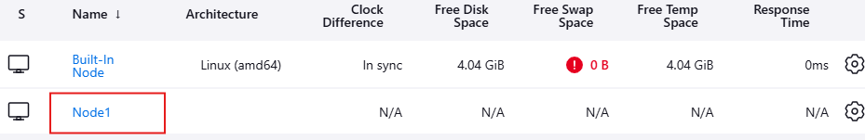

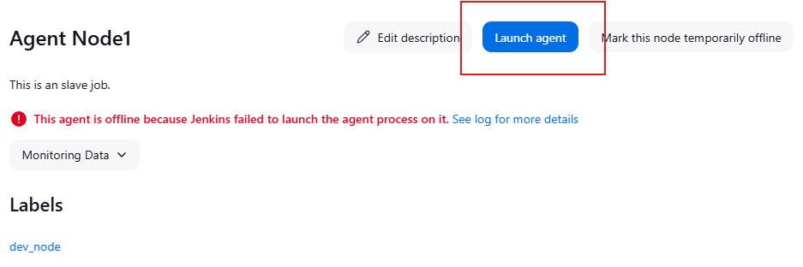

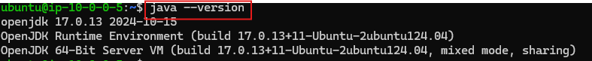

Slave job console output:

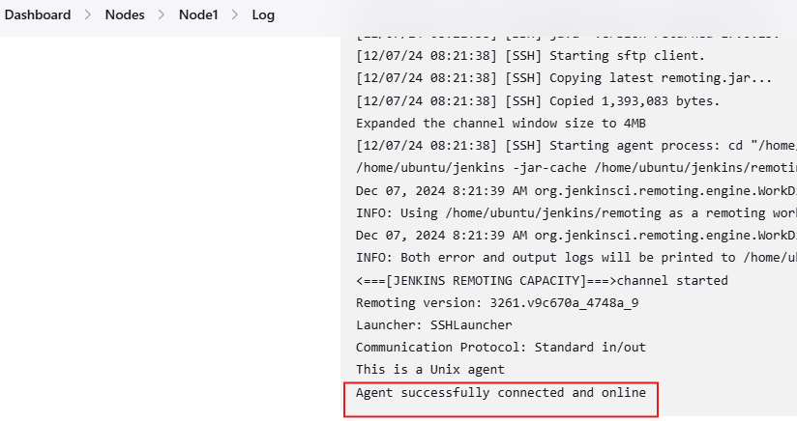

Create new job and assign it to a specific agent,

